Process Definition Document (PDD)

*Process Name: TopBoxOfficeMovies*

Table of Contents

**Introduction**1

Purpose of the Document 1

Objectives 1

Process Key Contact 1

Minimum Prerequisites for Automation 2

**As-Is Process Description**2

Process Overview 2

Applications used in the Process 3

As-Is Process Map 4

**To-Be Process Description**7

Detailed Process Map 7

Robot Type 10

Business Exceptions Handling 11

Known Exceptions 11

Unknown Exceptions 11

System Exceptions Handling 11

**Other Observations**12

**Additional sources of process documentation**12



# Introduction

## Purpose of the Document

The Process Definition Document outlines the business process chosen for automation using UiPath Robotic Process Automation (RPA) technology.

The document describes the sequence of steps performed as part of the business process, the conditions and rules of the process prior to automation and how they are envisioned to work after automating it, partly or entirely. This specifications document serves as a base for developers, providing them with the details required for applying robotic process automation to the selected business process.

## Objectives

The business objectives and benefits expected by the Business Process Owner after automation of the selected business process are:

* Create an excel file that contains the top 10 box office movies from “Rotten Tomatoes” website and their available information.
* Send the excel file to the list of mails saved in the Orchestrator asset.
* This process is to be done weekly, at 8:00 am Monday.

## Process Key Contact

The specifications document includes concise and complete requirements of the business process and it is built based on the inputs provided by the process Subject Matter Expert (SME)/ Process Owner.

The Process Owner is expected to review it and provide signoff for accuracy and completion of the steps, context, impact and a set of process exceptions. The details are to be included in the table below.

|  |  |  |  |
| --- | --- | --- | --- |
| Role | Name | Contact Details  (email & phone number) | Notes |
| Process Owner | Sherif Radwan | [sherif.gamal.298@gmail.com](mailto:sherif.gamal.298@gmail.com)  0201140818555 |  |
| Business Analyst | Sherif Radwan | [sherif.gamal.298@gmail.com](mailto:sherif.gamal.298@gmail.com)  0201140818555 |  |

## Minimum Prerequisites for Automation

|  |  |
| --- | --- |
| Met (Y/N) | Prerequisites |
| Y | A filled in and completed Process Definition Document |
| Y | Closure of any open process questions |
| Y | Environment set up |
| Y | Test Data to support development and testing |
| Y | User access and creation of user accounts (licences, permissions, restriction to create accounts for robots) |

# As-Is Process Description

## Process Overview

General information about the process selected for RPA prior to automation.

|  |  |  |
| --- | --- | --- |
| # | Item | Description |
| 1 | Process Full Name | TopBoxOfficeMovies |
| 2 | Process Area | Personal |
| 3 | Department | N/A |
| 4 | Process Short Description  (Operation, activity, outcome) | Email a list of mail addresses, with an excel sheet that contains the top 10 box office movies and their available information from “Rotten Tomatoes” website. |
| 5 | Role(s) required for performing the process | N/A |
| 6 | Process schedule and frequency | Weekly (at 8:00 am Monday) |
| 7 | # Of items processed /reference period | 10 |
| 8 | Process execution time | 1 min / movie |
| 9 | Peak period(s) | No peak period |
| 10 | Transaction Volume During Peak period | N/A |
| 11 | Total # of FTEs supporting this activity | 1 |
| 12 | Expected increase of volume in the next reference period | N/A |
| 13 | Level of exception rate | No expected exceptions |
| 14 | Input data | List of the mail addresses & “Rotten Tomatoes top box office movies” link; both saved as assets in the orchestrator. |
| 15 | Output data | Top 10 box office movies info saved in an excel sheet, and the sheet is sent to the required mail addresses. |

*Add more rows to the table to include relevant data for the automation process. No fields should be left empty. Use “n/a” for the items that don't apply to the selected business process.

## Applications used in the Process

The table includes a comprehensive list of all the applications that are used as part of the process to be automated to perform the given steps in the flow.

|  |  |  |  |  |  |
| --- | --- | --- | --- | --- | --- |
| # | Application Name & Version | System Language | Thin/Thick Client | Environment/ Access Method | Comments |
| 1 | Microsoft Edge  93.0.961.38 | English | Thin | PC | N/A |
| 2 | Microsoft Outlook  2016 | English | Thin | PC | The provided account must be signed in. |
| 3 | Microsoft Excel  2016 | English | Thin | PC | N/A |

*Add more rows to the table to include the complete list of applications.

## As-Is Process Map

**High Level As-Is Process Map:** This chapter depicts the As-Is business process at a High Level to enable developers to have a high-level understanding of the current process.

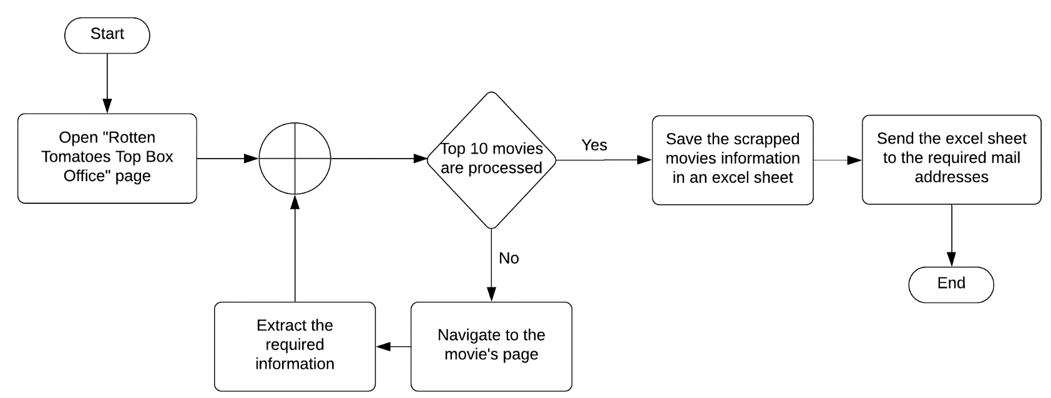

**Detailed Process Map:** This chapter depicts the As-Is business process at a detailed view to enable process owners to document their process

|  |  |  |  |
| --- | --- | --- | --- |
| # | Step Action/Description | Screenshot | Remarks |
| 1 | Open Microsoft Edge on the “Top Box Office – Rotten Tomatoes” page link <https://www.rottentomatoes.com/browse/in-theaters/> |  | Check if the URL is correct, if not stop the process. |
| 2 | For each top 10 movies in the list, perform the following two steps. | N/A | N/A |
| 2.A | Open the movie page. |  | N/A |
| 2.B | Get the movie Name and from the (MOVIE INFO) section get the following information -if available:   * Synopsis * Rating * Runtime * Genre * Release date * Original language * Box office * Director * Producer * Writer * Production Co * URL |  | Some of the required information may not exists, if so, put “N/A” in its value. |
| 3 | Create an excel file in the project directory with the name  “Top 10 Box Office Movies - ddMMyyyy.xlsx”  The sheet name is  “Rotten Tomatoes” |  | If the file already exists, override the data in the excel sheet. |
| 4 | Write the scrapped movies info in the created excel file. |  | Change the color of the header to “Yellow”, for better readability. |
| 5 | Attach the excel file to a mail and send it to the list of required receivers addresses;  The subject of the mail is  “Top 10 Box Office Movies | dd/MM/yyyy Update”  And the body is  “Hi,  Find attached the top 10 box office movies on “Rotten Tomatoes”.  Regards,  Ui Bot”. |  | N/A |
| 6 | Close all the applications that are used in the process (Edge, Excel, Outlook). | N/A | N/A |

# To-Be Process Description

## Detailed Process Map

**High Level To-Be Process Map:** This chapter depicts the To-Be automation process at a High Level to enable developers/COE to have a high-level understanding of the to be developed process.

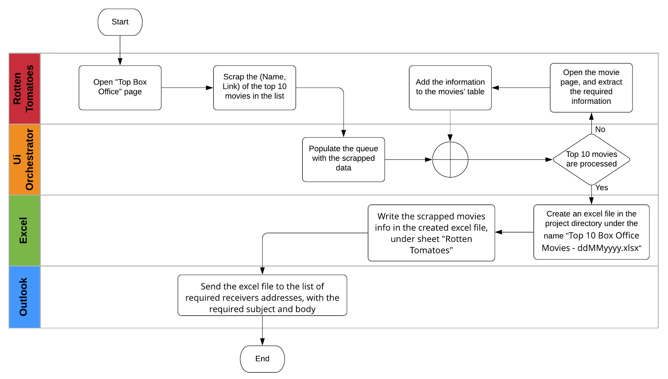

**Detailed Process Map:** This chapter depicts the To-Be automation process at a detailed view to enable developers/COE to see the workflows involved in the RPA solution

|  |  |  |  |  |  |
| --- | --- | --- | --- | --- | --- |
| **Workflow Name** | **Description** | **Pre-conditions** | **Post-actions** | **Arguments** | **Notes** |
| KillAllProcesses | Force the termination of the Windows processes representing applications used in the process being automated. | N/A | All the processes name in the passed array -if any- are terminated successfully. | i/p:  in_ProcessesNamesArr : string  o/p:  N/A | N/A |
| TakeScreenshot | Capture a screenshot, log its name and location and save it with the PNG extension. If no specific filepath is passed as argument, it saves the image in the folder specified by in_Folder. | N/A | Screenshot of the whole screen is taken and saved successfully. | i/p:  io_FilePath : string  in_Folder : string  o/p:  io_FilePath : string | N/A |
| RottenTomatoes_GetTop10Movies | Get rotten tomatoes box office page from orch assets, then open it on edge and scrap the top 10 movies in the list. | N/A | out_Top10MoviesDT contains the names and links of the top 10 box office movies. | i/p:  in_OrchFolder : String  o/p:  out_Top10MoviesDT : DataTable | If Rotten tomatoes did not open -which means that the URL is incorrect- end the process. |
| Orchestrator_PopulateQueue | Populate the orch queue with the top 10 box office movies.  Each item should have (Name, URL) and the reference is  “MovieName_ddmmyyyy”. | The passed DataTable (in_Top10MoviesDT) contains the names and links of the top 10 box office movies. | The queue is populated successfully. | i/p:  in_Top10MoviesDT : DataTable  in_QueueName : String  in_OrchFolder : String  o/p:  N/A | N/A |
| Orchestrator_ProcessTransactions | Process the transactions in the orch queue, invoke the required workflows, and set the status of the transactions afterwards. | The top 10 movies are uploaded to the orch queue. | All the transactions in the orch queue are processed and evaluated successfully, and the out_Top10MoviesDT contains all the required info of the top 10 movies. | i/p:  in_QueueName : String  in_OrchFolder : String  in_OutlookAccount : String  o/p:  out_Top10MoviesDT : DataTable | N/A |
| RottenTomatoes_GetMovieInfo | Navigate to the passed movie URL, then extract the required info and add it to the io_Top10MoviesDT Datatable output argument. | The passed movie URL is correct. | All the required info are extracted and added to the io_Top10MoviesDT DataTable successfully. | i/p:  io_Top10MoviesDT : DataTable  in_MovieURL : String  in_MovieName : String  o/p:  io_Top10MoviesDT : DataTable | Some of the movie’s info may be missing from the moiveInfo section in the movie’s page, if so, set the value of the corresponding info to “N/A”. |
| Excel_SaveMoviesInfo | Save the passed in_Top10MoviesDT in an excel file.  The file name is “Top 10 Box Office Movies - ddMMyyyy.xlsx”, and the sheet name is “Rotten Tomatoes”. | The passed DataTable contains the info of the top 10 box office movies. | The movies info is save successfully. | i/p:  in_Top10MoviesDT : DataTable  o/p:  out_MoviesFilePath : String | The file should be saved under the “Data\Output” folder in the project directory. |
| Outlook_SendMoviesUpdate | Get the required mail addresses from the orch assets, and send to them, the movies excel file, with the required subject and body. | The passed movies excel file exists. | Update mails are sent successfully. | i/p:  in_MoviesFilePath : String  in_OutlookAccount : String  in_OrchFolder : String  o/p:  N/A | The subject of the mail is  “Top 10 Box Office Movies | dd/MM/yyyy Update”  And the body is  “Hi,  Find attached the top 10 box office movies on “Rotten Tomatoes”.  Regards,  Ui Bot”. |

## Robot Type

|  |  |  |  |  |
| --- | --- | --- | --- | --- |
| # | Attended | Unattended | Trigger | Comments |
| 1 |  | 🗸 | Orchestrator trigger | Will be triggered every Monday on 8:00 am |

## Business Exceptions Handling

The Business Process Owner and Business Analysts are expected to document below all the business exceptions identified in the automation process. These can be classified as:

### Known Exceptions

The table below reflects all the business process exceptions encountered during the process evaluation and documentation. These are known exceptions that occurred before. For each of these exceptions, define a corresponding expected action that the robot should complete if it encounters the exception.

|  |  |  |  |  |
| --- | --- | --- | --- | --- |
| BE # | Exception Name | Step | Parameters | Action to be Taken |
| 1 | Incorrect RT URL | 1 | Rotten Tomatoes doesn’t open. | Log the exception and End the Process. |

### Unknown Exceptions

For all other unanticipated or unknown business (process) exceptions, the robot should:

* send an email to [*sheko4rpa@gmail.com*](mailto:sheko4rpa@gmail.com) and attach a screenshot of the screen with the error message.

## System Exceptions Handling

A comprehensive list of all errors, warnings or notifications should be consolidated here with the description and action to be taken, for each, by the robot.

Errors identified in the automation process can be classified as:

|  |  |  |  |  |
| --- | --- | --- | --- | --- |
| SE # | Exception Name | Step | Parameters | Action to be Taken |
| 1 | Incorrect Page URL. | 2.A | The page doesn’t open | Retry 3 times. |
| 2 | The Movies info is incomplete. | 4 | N/A | Retry 3 times, then stop the process. |
| 3 | The Excel file doesn’t Exist. | 5 | N/A | Retry 3 times, then stop the process. |

For all the other unanticipated or unknown system exceptions, send an email to **sheko4rpa@gmail.com** and attach a screenshot of the error message.

# Other Observations

Include below any other relevant observations you consider needed to be documented here.

* N/A

# Additional sources of process documentation

* N/A